Add 2 LEDS connected to the XBEE In (Green) /Out (Red). Also add these LEDS to the the 4 pin connector.

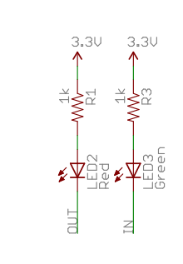

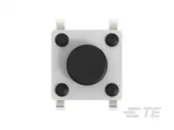

**1825910-6**

Finally add a push button connected to GPIO that will allow me to connect to code that will reset the wireless settings. It should be able to detect how long I have held the button down to know which function to do.

We have an additional use case for this board, so the xbee should be facing out and centered on the board so it could work in this way with an external antenna going outside. And the 5 pin connector should face the opposite direction of the antennas as you can see in the picture.,

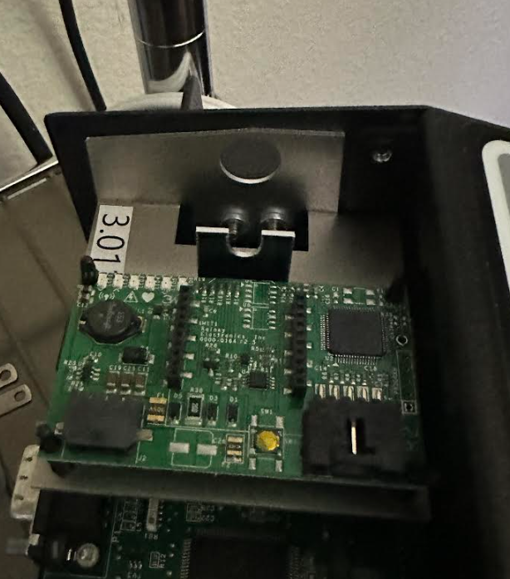

Here is my thought:

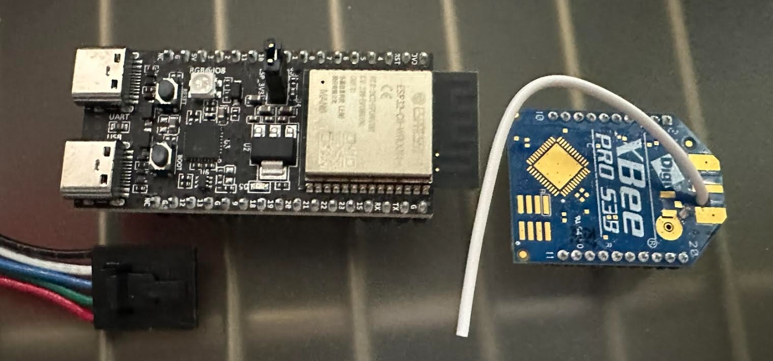

Internal Notes:

Cable end: 50375043 5264 (Mini-SPOX) connector to board